The Missouri Compromise and the Compromise of 1850
Answer the questions that follow on your own paper using complete sentences. The questions are under the section they apply to.
Slavery had come to America in 1619. It existed through the American Revolution, even after Thomas Jefferson penned his famous lines in the Declaration of Independence, "All men are created equal. They are endowed by their creator with certain unalienable rights. That among these are life, liberty, and the pursuit of happiness." Obviously, slaves were not part of this equation. When it came time to write the Constitution, the word "slavery" was never used. Instead, the framers chose to use the term "other people." These other people were counted as 3/5 of a person for the purposes of representation in Congress according to the 3/5 Compromise. This compromise kept slavery in the United States intact. The founders also decided not to do anything about the issue of slavery for twenty years. Someone else would have to deal with it.
In 1820 with the admission of Missouri to the Union, the issue of slavery came up again. There was already a great deal of tension between the North and the South. The South was highly agricultural. It wanted to keep slavery as a way of life on their plantations. The North, which was far more industrial, saw this "peculiar institution" as unnecessary and increasingly morally wrong. One way the government tried to limit the tension was by keeping the number of slave and free states equal. So, in 1820, when Missouri met the requirements for statehood and applied for admission to the Union as a slave state, there was a problem. The balance of free and slave states would be destroyed.
The Missouri Compromise seemed to solve the problem by admitting Missouri as a slave state and Maine as a free state, keeping the number of free and slave states equal. It also divided the rest of the Louisiana Purchase into slave and free territory.
1. What was the name of the compromise that dealt with slavery that was written into the Constitution?
2. What did the compromise do?
3. How did the Missouri Compromise solve the problem of the balance of free and slave states?
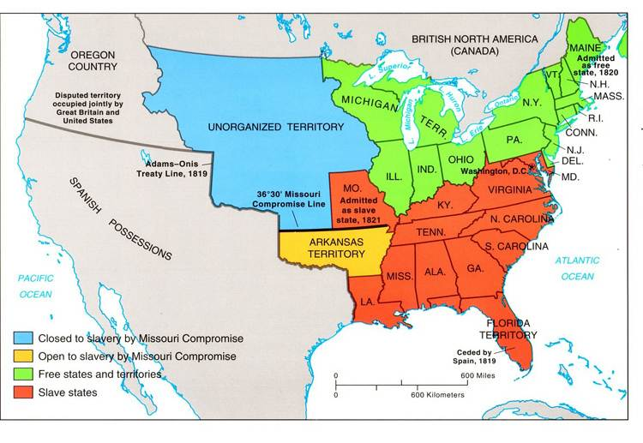
Look at the map above for the next two questions.
4. What year was Maine admitted to the Union? Was it a free or slave state?
5. What year was Missouri admitted to the Union? Was it a free or slave state?
Excerpt from the Missouri Compromise, 1820
SEC. 8. And be it further enacted. That in all that territory ceded by France to the United States, under the name of Louisiana, which lies north of thirty-six degrees and thirty minutes north latitude, not included within the limits of the state, contemplated by this act, slavery and involuntary servitude, otherwise than in the punishment of crimes, whereof the parties shall have been duly convicted, shall be, and is hereby, forever prohibited: Provided always, That any person escaping from slavery...may be lawfully reclaimed and conveyed back to the person (slave owner)...
After the Fugitive Slave Act was passed, if a runaway slave was caught, they had to be sent back to their "owners" by law.
6. What does this section of the document state about fugitive or "runaway" slaves?
The Compromise of 1850 and the Fugitive Slave Act
Henry Clay, U.S. senator from Kentucky, was determined to find a solution. In 1820 he had resolved a fiery debate over the spread of slavery with his Missouri Compromise. Now, thirty years later, the matter surfaced again within the walls of the Capitol. But this time the stakes were higher -- nothing less than keeping the Union together.
7. Who proposed the solutions for the Compromise of 1850?
There were several points at issue:
* The United States had recently acquired a vast territory -- the result of its war with Mexico. Should the territory allow slavery, or should it be declared free? Or maybe the inhabitants should be allowed to choose for themselves?
* California -- a territory that had grown tremendously with the gold rush of 1849, had recently petitioned Congress to enter the Union as a free state. Should this be allowed? Ever since the Missouri Compromise, the balance between slave states and free states had been maintained; any proposal that threatened this balance of free and slave states would almost certainly not win approval.
8. Did California want to be a free or slave state? Why was this a problem?
*There was a dispute over land: Texas claimed that its territory extended all the way to Santa Fe.
*Finally, there was Washington, D.C. Not only did the nation's capital allow slavery, it was home to the largest slave market in North America.
On January 29, 1850, the 70-year-old Clay presented a compromise. For eight months members of Congress, led by Clay, Daniel Webster, Senator from Massachusetts, and John C. Calhoun, senator from South Carolina, debated the compromise. With the help of Stephen Douglas, a young Democrat from Illinois, a series of bills that would make up the compromise were ushered through Congress.
According to the compromise, Texas would relinquish the land in dispute but, in compensation, be given 10 million dollars -- money it would use to pay off its debt to Mexico. Also, the territories of New Mexico, Nevada, Arizona, and Utah would be organized without mention of slavery. (The decision would be made by the people who lived in the territory later, when they applied for statehood.) Regarding Washington, the slave trade would be abolished in the District of Columbia, although slavery would still be permitted. Finally, California would be admitted as a free state. To pacify slave-state politicians, who would have objected to the imbalance created by adding another free state, the Fugitive Slave Act was passed.
9. In the compromise, how was the issue of slavery solved in the territories of New Mexico, Nevada, Arizona, and Utah?
10. What happened to the issue of slavery in the District of Columbia.?
11. When California was admitted as a free state, what was passed to pacify [to calm someone who is angry] southern states?
The Fugitive Slave Law of 1850 made any Federal marshal or other officers of the law repsonsible for arresting in runaway slaves. Those who did not arrest an alleged runaway slave liable to a fine of $1,000. Law-enforcement officials everywhere now had a duty to arrest anyone suspected of being a runaway slave on no more evidence than a slave owners sworn testimony that they owned the runaway. The suspected slave could not ask for a jury trial or testify on his or her own behalf. In addition, any person aiding a runaway slave by providing food or shelter was subject to six months' imprisonment and a $1,000 fine. Officers who captured a fugitive slave were entitled to a bonus for their work. Since any suspected slave was not eligible for a trial this led to many free blacks being sent into slavery as they had no rights in court and could not defend themselves against accusations.
12. What did the Fugitive Slave Act require officers of the law to do?
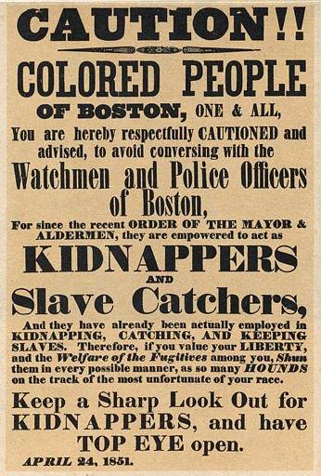
13. What does the poster above warn the colored people of Boston about?
For slaves attempting to build lives in the North, the new law was disaster. Many left their homes and fled to Canada. During the next ten years, an estimated 20,000 blacks moved to the neighboring country. For Harriet Jacobs, a fugitive living in New York, passage of the law was "the beginning of a reign of terror to the colored population." She stayed put, even after learning that slave catchers were hired to track her down. Anthony Burns, a fugitive living in Boston, was one of many who were captured and returned to slavery. Free blacks, too, were captured and sent to the South. With no legal right to plead their cases, they were completely defenseless.
14. Why do you think many slaves fled to Canada after the passage of the Fugitive Slave Act?

Passage of the Fugitive Slave Act made abolitionists all the more resolved to put an end to slavery. The Underground Railroad became more active, reaching its peak between 1850 and 1860. The act also brought the subject of slavery before the nation. Many who had previously been ambivalent about slavery now took a definitive stance against the institution.
15. What organization became more active after the passage of the Fugitive Slave Act?
The Compromise of 1850 accomplished what it set out to do -- it kept the nation united -- but the solution was only temporary. Over the following decade the country's citizens became further divided over the issue of slavery. The rift would continue to grow until the nation itself divided.
16. What did the Compromise of 1850 accomplish?
17. What issue would divide the country for the next decade?
18. What do you think would be the result of the divisions between free and slave states?
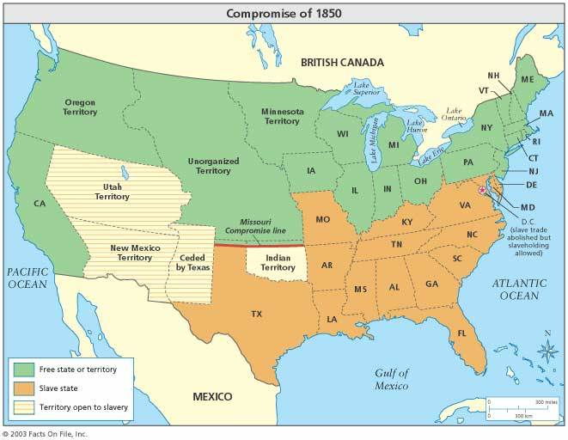
19. Look at Compromise of 1850 map. What were the territories open to slavery?
20. What do you think might happen in the territories that were open to slavery?

