The Oregon Trail

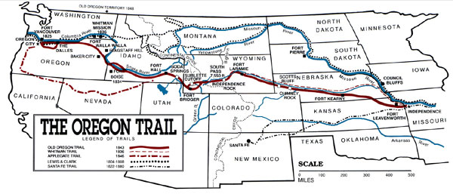

The Oregon Trail became one of the key migration routes that pioneers crossed on their way to the vast west. Spanning over half the continent the trail proceeded over 2,170 miles west through territories that would later become Missouri, Kansas, Nebraska, Wyoming, Idaho, and Oregon. The long journey through endless plains, rolling hills, and mountain passes, began in Independence, Missouri and ended at the Columbia River in Oregon.
The route of the Oregon Trail began to be scouted as early as 1823 by fur traders and explorers. By the 1830s, it was used regularly by mountain men, traders, missionaries, and military expeditions.
At the same time, small groups of individuals and the occasional family attempted to follow the trail, with some succeeding in arriving at Fort Vancouver in Washington.
Albert Bierstadt's Oregon Trail, 1869On May 16, 1842 the first organized wagon train on the Oregon Trail set out from Elm Grove, Missouri, with more than 100 pioneers. On May 22, 1843, what is known as the Great Migration, with up to a 1,000 settlers, live stock and more, in a massive wagon train, departed to follow the same route from Independence Missouri, arrived in the Willamette Valley. Hundreds of thousands more would follow, especially after gold was discovered in California in 1849.
While the first few parties organized and departed from Elm Grove, Missouri, the Oregon Trail's generally designated starting point was Independence or Westport, Missouri. The trail ended at Oregon City, Oregon, which was the proposed capital of the Oregon Territory at the time. However, many settlers branched off or grew exhausted short of this goal and settled at convenient or promising locations along the way.
At many places along the trail, alternate routes called "cutoffs" were established, either to shorten the trail, or to get around difficult terrain. The Lander and Sublette cutoffs provided shorter routes through the mountains than the main route, bypassing Fort Bridger, Wyoming. In later years, the Salt Lake cutoff provided a route to Salt Lake City.
The Oregon Trail was too long and arduous for the standard Conestoga wagons used in the eastern U.S. for most freight transport. These big wagons had a reputation for killing their oxen teams approximately two thirds along the trail and leaving their unfortunate owners stranded in desolate, isolated territory. The only solution was to abandon all belongings and traipse onward with the supplies and tools that could be carried or dragged. In one case in 1846, the Donner Party, en route to California, was stranded in the Sierra Nevada in November and had to resort to cannibalism to survive.
This led to the rapid development of the prairie schooner. Though this wagon looked similar, it was approximately half the size of the big Conestogas and also manufactured in quantity by the Conestoga Brothers. It was designed for the conditions and was a marvel of engineering in its time.
Pioneers on the Oregon Trail followed various rivers and used landmarks along the trail to guide their way and gauge their progress. Within Nebraska, the Oregon Trail followed the Platte River and then the North Platte River into Wyoming. Along this part of the journey, the Great Plains started giving way to bluffs and hills that were the precursor of the Rocky Mountains. After crossing the Rockies through South Pass, the trail followed the Snake River to the Columbia River. From there, emigrants had the option of either rafting down the Columbia to Fort Vancouver, or taking the Barlow Road to the Willamette Valley and other destinations in what are now the states of Washington and Oregon.

