Topic: ______________________________  ______________________________  EQ: ______________________________  ______________________________ | Name: ________________________________  Date: ________________________________  Core: ____

Question | NOTES
Chapter 10 – Section 1: “Photosynthesis” Classwork and Study Notes

Sources of Energy

- The process by which a cell captures energy in sunlight and uses it to make food is called photosynthesis. “Photo” means “light” and “synthesis” means “putting together”.

- Nearly all living things obtain their energy directly or indirectly from the energy of sunlight captured during photosynthesis. We learned about this during our study of the food web. The diagram below, which we studied previously, shows how the energy from the sunlight is used by plants and grasses to make their own food which in turn supplies energy to the animals that eat these plants and grasses.

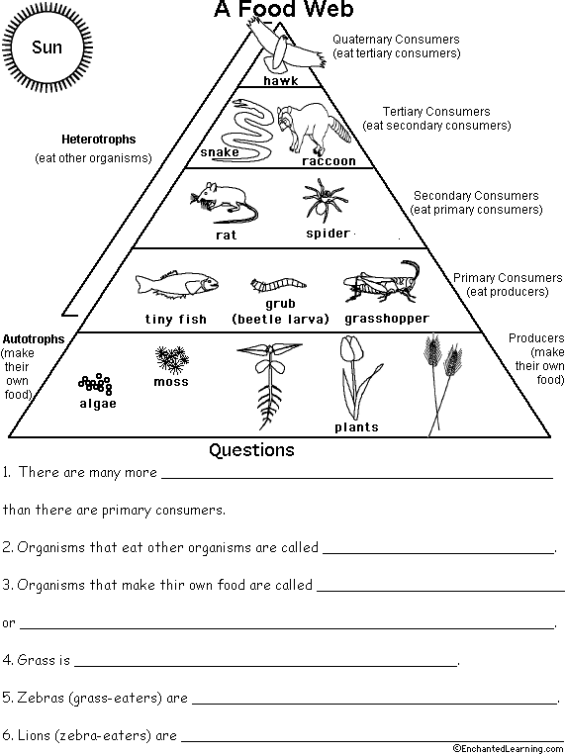

- As noted above, an organism that makes its own food is called an autotroph and organisms that cannot make their own food are called heterotrophs. Many heterotrophs obtain their energy or food by eating other organisms as shown in the above food web diagram.

- There are 2 stages of photosynthesis and they

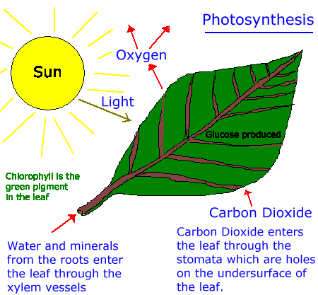
Stage 1 Chloroplasts in the plant cells capture energy from sunlight and power the cell similar to the way a solar cell makes electrical power.
Stage 2
The cells use the captured sunlight energy and CO₂ and H₂O to produce sugars (glucose). A product of this chemical reaction is O₂ which we and other organisms breathe.

- As noted above, the 2 raw materials needed to produce the food are water and carbon dioxide. The water enters through the roots of the plant or tree and the carbon dioxide enters through openings on the underside of the leaf called the stomata. Once in the leaves, the water and carbon dioxide move into the chloroplasts and the main pigment inside the chloroplast is chlorophyll which is green in color.

- Once inside the chloroplasts, the H₂O and CO₂ undergo a complex series of chemical reactions which are powered by the captured energy of the sun. These reactions produce chemicals and one reaction product is sugar (a type of carbohydrate) that has 6 carbon atoms and has the chemical formula C₆H₁₂O₆.

- The second reaction product is oxygen (O₂) which exits the leaf through the stomata. Without this reaction and its release of oxygen we would not have enough O₂ in the atmosphere to breathe.

- From the information above, answer the following questions in the space provided below:

  - What is the energy in the 1st stage of photosynthesis used for? _________________________
______________________________________________________________________________

  - How is chlorophyll like a solar cell? _________________________________________________
______________________________________________________________________________

  - What happens in the 2nd stage of photosynthesis? ____________________________________
______________________________________________________________________________

  - Do the soil and the roots of a plant provide it with food? Circle one YES NO

The Photosynthesis Equation

- The chemical reaction of photosynthesis can be described by the following equation:
Sunlight Energy

6CO₂ + 6H₂O C₆H₁₂O₆ + 6O₂

(carbon dioxide) (water) (a sugar) (oxygen)

- The raw materials (in this case 2 molecules) for the above photosynthesis chemical reaction are listed on the left hand side of the equation and the products of the reaction are listed on the right hand side. The arrow indicates the external event needed to make the reaction occur, in this case sunlight.

- Note that a chemical equation must have the same number of elements on both sides of the equation. For the 4 noted molecules in the above equation, list the number of carbon, hydrogen and oxygen elements on both the left and right sides of the equation. Write your answers below:

Element Number on Left Side Number on Right Side

Carbon __________ ____________
Hydrogen __________ ____________
Oxygen __________ ____________

- Did you know that when you eat food from plants like fruits and vegetables, you are eating the stored energy contained in the fruit or vegetable?

Summary:

