Topic: ______________________________  ______________________________  EQ: ______________________________  ______________________________ | Name: ________________________________  Date: ________________________________  Core: ____

Question | NOTES
Chapter 9 – Section 2: “Looking Inside Cells – Part 1” Classwork and Study Notes

Enter the Cell

- As we have studied, cells are in all living organisms. They are very tiny. There are even smaller structures inside a cell and these are called organelles. Organelles carryout specific functions within a cell just each organ in your body and those of animals carryout a specific function.

- Cell Wall – To first enter a cell, you must go through the cell wall which is a rigid layer of nonliving material that surrounds the cells of plants and some other organisms. The cells of animals do not have a cell wall. A plant’s cell wall is mostly made of cellulose which protects and supports the cell. Although the cell wall prevents a number of materials from entering the cell, it does allow water and oxygen to easily pass through.

- Once you pass through the cell wall, you next encounter the cell membrane. All cells have membranes and the cell membrane controls what substances come into and out of a cell. Food, oxygen and other necessary materials pass into the cell by way of the cell membrane and waste products pass out through the cell membrane. The cell membrane helps to keep harmful substances from entering the cell.

- What is the function of the cell membrane? Write your answer here _____________________
_________________________________________________________________________________
_________________________________________________________________________________

The Nucleus

- The nucleus (see the picture below) is located inside the cell and is essentially the brain of the cell. It directs all of the activities of the cell and consists of 3 main parts. They are:
- The nuclear envelope, and
- The chromatin, and
- The nucleolus

- Nuclear Envelope Notice that the nucleus is surrounded by the nuclear envelope which protects the nucleus. Materials pass in and out of the nucleus through pores in the nuclear envelope.

- Chromatin The thin strands of material in the nucleus are called the chromatin, which contain genetic material or the instructions for directing the cell’s functions.

- Nucleolus The nucleolus is where ribosomes are made in the nucleus. Ribosomes are the organelles where proteins are produced and these proteins are important chemicals in the cells.

Organelles in the Cytoplasm

- A substance called cytoplasm surrounds the nucleus. It is a gel-like fluid and is constantly moving. Many cell organelles are located in the cytoplasm. Some of these cell organelles are:

  - Mitochondria These structures are rod-shaped and are known as the “powerhouses” of thee cell because they convert energy in food molecules to energy that the cell can use to carry out its functions.

  - Endoplasmic Reticulum Further inside the cell is the endoplasmic reticulum which is a series of passageways that carry proteins and other materials from one part of the cell to another.

  - Ribosomes Attached to the endoplasmic reticulum are small, grain-like bodies called ribosomes. Other ribosomes float in the cytoplasm. Ribosomes, as noted above, function as factories to produce proteins. Some of the newly made proteins are released through the wall of the endoplasmic reticulum where they are transported to the Golgi bodies.

  - Golgi Bodies The Golgi Bodies can be thought of as the cell’s mail room. The Golgi Bodies receive proteins and other newly formed materials from the endoplasmic reticulum and then package them and distribute them to other parts of the cell.

  - Chloroplasts Plants and some other organisms have a green organelle called chloroplasts. These green structures capture energy from sunlight and use it to produce food for the cell. It is the chloroplasts that make leaves green.

  - Vacuoles Thee vacuole is a large water-filled sac that floats in the cytoplasm. Vacuoles are the storage areas of cells. They store food and other materials needed by the cell. Most plant cells have 1 large vacuole and some animal cells do not have vacuoles but others do. Vacuoles can also store waste products.

  - Lysosomes Lysosomes are small, round structures containing chemicals that break down certain materials in the cell. Lysosomes also break down old cell parts and release the substances so they can be used again. The lysosomes of the cell function like a cleanup crew.

Specialized Cells and Tissue

- Plants, animals and mammals (including ourselves) contain many specialized cells. Specialized cells are often organized into tissues, organs and organ systems. Examples of specialized cells are nerve cells, red blood cells, liver cells and so on. A group of similar specialized cells are called tissue.

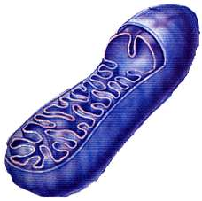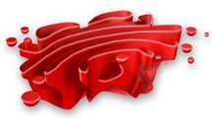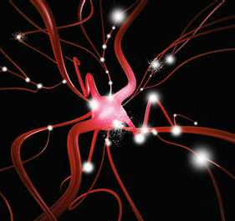
Mitochondria Golgi Body Nerve Cell

Summary:

