Civil War Technology
Civil War technology led historians to call the American Civil War the first modern war because of the array of new technology with which it was fought. The new technology ranged from weapons to cameras and telegraphs to tin cans. New weapons allowed soldiers to be more effective, but this new technology also meant that more soldiers were killed.
Photography meant that the war was the first conflict to be accurately recorded with real-life images, rather than an artist’s impressions. Telegraphs meant that commanders could communicate more quickly with each other and with their respective presidents. Tin cans allowed food to be shipped longer distances without spoiling, although the fare offered in these convenient packages were not as varied or as tasty as modern canned goods.
Of all these advances, the advances in weaponry most affected the average soldier on the field. During the wars first year, most soldiers on both sides carried the old smoothbore muskets, which were slow to reload and only had an effective firing range of eighty yards.
The next year, the Union began supplying its troops with rifles, which were quicker to load and put a spin on a bullet, increasing its accuracy and firing range. By 1863, most infantrymen on both sides had the new rifles.
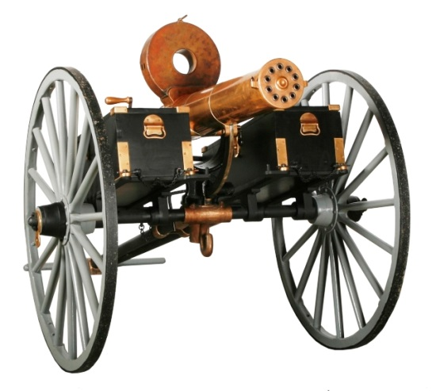
Another improvement was a new bullet, called the minie ball, which was easier to load into a rifle than the older type of ammunition. The new guns improved a soldier’s fighting effectiveness, but they also inflicted more causalities than the older weapons. Minie balls caused more widespread wounds and tissue damage than the older ammo and Civil War surgeons were hard pressed to deal with these more extensive injuries.
Other new Civil War technology included the Gatling gun and the torpedo. The Gatling gun, a kind of machine gun on wheels, was not used much during the war, but when it was used it was devastating. The South made extensive use of torpedoes, which were not the self-propelled missiles of today, but more like mines. Some torpedoes could be detonated electronically when an enemy vessel neared.
Civil War technology also saw the first use of submarines. The Confederates used steam-powered small submarines dubbed “Davids,” after the biblical youth who battled the giant Goliath. The Union army also attempted to use submarines, commissioning the forty-seven foot Alligator. The Alligator was initially propelled by oars, but these proved unwieldy and were replaced with a screw propeller. The Union submarine did not prove to be an effective weapon and it sank off Cape Hatteras in 1863.
Gatling Gun
More reliable Civil War technology was also used during the war. Civil War locomotives were invaluable for carrying men and supplies; the Union Railroad Train system was more effectively organized than the Confederate Railroads. Two-thirds of the nation’s rails were in the north. Yet, the South quickly learned to use its rails to great advantage. While Civil War locomotives improved physical transport, the telegraphs improved communications. Field commanders were able to communicate with one another far more rapidly than the old method of sending a messenger on horseback. At one point, Lincoln sat in the Washington telegraph office through the night, sending orders to his commanders as the battle logistics changed. Telegraphs were also a very helpful to folks on the home front looking to hear the latest news. Some Civil War soldiers grew adept at putting up temporary telegraph wires, which the enemy often cut.
Photojournalism also allowed the people back home to understand what was going on more effectively than they had in past wars. While the cameras were cumbersome by today’s standards, they gave an accurate record of events. Famed Civil War photographer Mathew Brady provided an invaluable historical record.
Unfortunately, Civil War technology to preserve food was not as well advanced as many other areas were during the conflict. The soldiers did have the luxury of canned foods, but these were not seasoned in the way we are accustomed to and were probably quit bland; the main canned item was pork and beans, but without spices or tomato sauce. Of course, refrigeration was lacking as well, limiting soldiers in the field to salted meats, since these did not spoil easily.
Because of the many advances in Civil War technology used during it, the American Civil War can truly be called the first modern war. It was the last major war to use wooden ships in combat and the first to use armored ships. After the war, experts built on technology, such as the Gatling gun, torpedoes, ironclads and submarines, to make newer, more effective weapons for future conflicts.

