Secession and the Confederate States of America
Abraham Lincoln was elected president in November 1860. In the months before Lincoln’s March 1861 inauguration, talk of Southern secession became more common. In his annual address to Congress at the end of 1860, President James Buchanan announced that he would not act against rebellious states. Buchanan believed the federal government had no power to prevent states from leaving the Union.
On December 20, 1860, South Carolina was the first state to secede from the United States. In January 1861 five more states—Georgia, Florida, Alabama, Mississippi, and Louisiana—followed. Two months later these states, now joined by Texas, ratified the constitution of the newly formed Confederate States of America. Jefferson Davis, a West Point Military Academy graduate, was inaugurated as the president on February 18, 1861.
Two weeks after Davis began his term, Lincoln was inaugurated as the 16th president of the United States. You might recall that Lincoln had been elected because the majority of voters wanted to keep the United States together and to keep slavery from spreading to the free states.

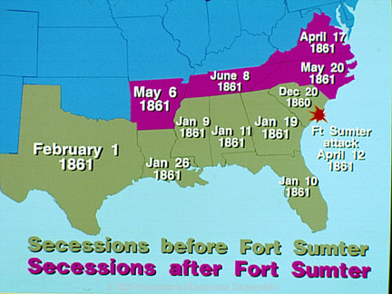
*The attack on Fort Sumter marked the beginning of the Civil War. This event took place April 12, 1861.

