Social Issues, 1834-1865
In 1834, the National Antislavery Society organized the Underground Railroad, which comprised the combined efforts of both white and black abolitionists to aid some 100,000 enslaved persons to find their way to freedom.
In 1838, the Underground Railroad became formally organized with black abolitionist Robert Purvis at the helm. Under direction of the railroad's "agents," numerous slaves made spontaneous escapes from the Confederate South, while others used highly organized systems.
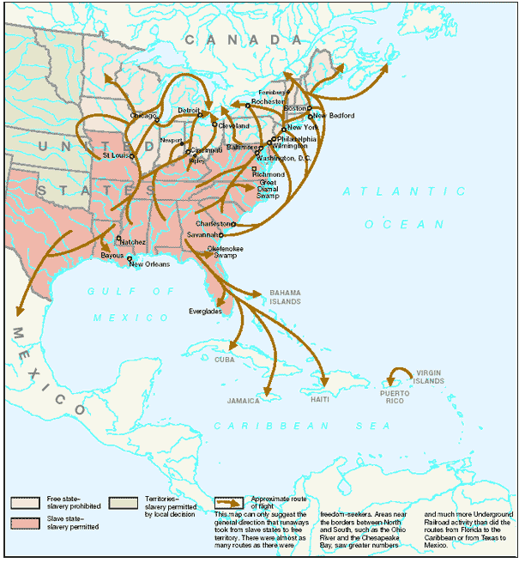
Diversity
The Underground Railroad spanned 29 states, as well as Canada, Mexico, and the Caribbean. Its "railways" were back roads, swamps, caves, forests, rivers and streams. It is believed that as many as 100,000 enslaved persons may have escaped in the years between the American Revolution and the Civil War, using this network of aid and assistance.
The Underground Railroad was neither a tunnel underground nor was it a railroad. It was, however, an escape network of courageous non-government rebels assisting fugitives from slavery. The network also provided an opportunity for anti-slave white Americans to take a stand and play an important role in undermining the industry called slavery.
Rescues of arrested fugitives in the North were common occurrences for those determined to make the railroad work. The network's marvelously effective communication was made up mostly of unwritten material — a kind of secret society message system. The desire and passion lay on the side of the slaves and there was little any slaver could do about it. Individual acts of bravery meant that for some, the ultimate sacrifice had to be given in their perilous quest of freedom.
Before the railroad
Most African-American slaves resisted enslavement at some point in their lives. Prior to the Underground Railroad's development, slaves had attempted, on numerous occasions, to find a better way of life. They used any means necessary to rebel against the inhumane system of slavery. Many individuals resorted to work slowdowns, sickness, sabotage, self-mutilation, and even the destruction of property.
Running away also was common for owned individuals to attempt. In fact, slaves had been escaping their masters and creating some of the earliest known paths of the Underground Railroad during the late 18th century. Called maroons, those runaways formed their own secret communities throughout Virginia's Great Dismal Swamp, and even as far south as in the Florida Everglades among the Seminole Indians.
Small revolutions also took place prior to the official formation of the railroad. One major uprising, called "Turner's Rebellion," occurred in Southampton County, Virginia, 1831. Led by enslaved preacher Nat Turner, a group of 70 slaves murdered some 50 whites — men, women, and children. In retaliation, many whites slaughtered not only the persons responsible (including Turner), but hundreds of other innocent blacks.
Murders also were committed against slaves as a result of what slave holders called insubordinate behavior.
The escape
Known as "Moses" to many slaves, Harriet Tubman has become one of the most famous persons to help enslaved African Americans find freedom, and return to help aid others in their pursuit of it.
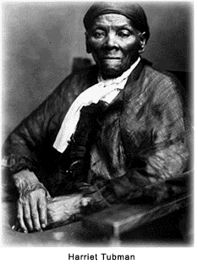
Along one of Tubman's railroads, freedom seekers were given such instructions as: Follow the North Star; travel using the cover of Mother Nature; and approach homes with lanterns on hitching posts along the way to find safe houses for food and shelter.
Such other courageous agents on the railroad as William Still, David Ruggles, Calvin Fairbank, Josiah Henson, and Erastus Hussey, have been credited with aiding thousands of slaves to freedom. However, those men are just a few of the estimated hundreds that contributed to the effort. The total number of runaways and guides who were part of the Underground Railroad will never be known, owing to the movement's secrecy.
Men like Thomas Garrett, a good friend of Tubman’s, worked on the Underground Railroad for nearly 40 years. Once Garret was arrested and fined $5,400, but that did little to stop his assistance of those in need.
Many slaves escaped from the South, then traveled into the western territories, Mexico, the Caribbean, and even Europe. Some runaways took refuge in such cities as Baltimore, Maryland and New Orleans, Louisiana, and blended into the free black population. The majority, however, made brave excursions north along various routes of the Underground Railroad to a better life in many parts of Canada — finding refuge much of the time with members of such religious groups as Quakers, Methodists, and Baptists.
Slaves passed information about methods of escape by word of mouth: in stories and through songs. No actual trains existed on the Underground Railroad, but guides like Tubman were called "conductors" and the hiding places that they used were known as "depots" or "stations." Alliance, Ohio was one of those stations.
Runaways escaped to the North along a generously connected series of courses that reached through the southern border states. Guided north by the stars, and sometimes singing such traditional songs as Follow the Drinking Gourd, most refugees traveled at night on foot — taking advantage of Tubman's instructions (and those of other conductors) to use the natural protections offered by swamps, bayous, forests, and waterways.
Fleeing men and their families were often separated. The overwhelming desire to avoid any more suffering and, more often than not, to preserve one's life, frequently resulted in the basic family unit's disintegration.
Just escaping the south into the Union states did not necessarily make life safe. Federal marshals were hot on the tracks of slaves; if captured, they were extradited to their former plantations.
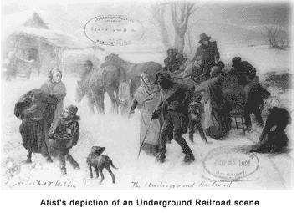
To reduce the numbers of escaping slaves, owners kept them illiterate and totally ignorant of geography. Owners even went so far as to try to keep slaves from learning how to tell directions. The following is an example of one of the many songs that escapees used for directions on their way to freedom.
When the sun comes back and the first quail calls, follow the drinking gourd.
For the old man is awaiting for to carry you to freedom, if you follow the drinking gourd.
The riverbank makes a very good road, the dead trees show you the way, left foot, peg foot, traveling on, follow the drinking gourd.
The river ends between two hills, follow the drinking gourd.
There's another river on the other side, follow the drinking gourd.
Where the great big river meets the little river, Follow the drinking gourd.
For the old man is a-waiting to carry you to freedom, if you follow the drinking gourd.
- Harriet Tubman
Fugitive Slave Act
The Fugitive Slave Act of 1850 gave slave owners the right to recapture and extradite escaped slaves with the assistance of federal marshals. To help battle the evidently successful Underground Railroad, one of the provisions of the Compromise of 1850 sanctioned fines and prison sentences for individuals who assisted escapees.
Unfortunately for the northern states, the re-enslavement act brought the reality of slavery to a Union that was supposed to be against it. Traders quickly became bounty hunters while kidnaping free African Americans during this period, when they sold their catch back to southern slave owners. Most runaways during this period who were able to flee the Fugitive Slave Law, found residence in other countries.
It wasn't until Lincoln's 1863 Emancipation Proclamation that slaves began to entertain hopeful thoughts of a truly righteous life. By the end of the Civil War in 1865, the 13th Amendment became reality — abolishing slavery permanently.
Never forget
In 1990, Congress directed the National Park Service to study how to best interpret and commemorate the Underground Railroad, emphasizing the approximate routes taken by slaves escaping to freedom before the Civil War.
The study was completed in cooperation with an advisory committee representing experts in historic preservation, African-American history, United States history, and members of the general public with special interest and experience in the Underground Railroad.
Today, 29 states that once were a part of the Underground Railroad network display more than 400 historical markers and monuments.
If there is no struggle, there is no progress. Those who profess to favor freedom, and deprecate agitation, are men who want crops without plowing up the ground, they want rain without thunder and lightning.
- Frederick Douglass.
---- Selected Quotes ----
Quotes regarding Underground Railroad.
By Harriet Tubman
I was the conductor of the Underground Railroad for eight years, and I can say what most conductors can't say — I never ran my train off the track and I never lost a passenger.

